SAGE Testing in Kiosk Mode on Chromebooks

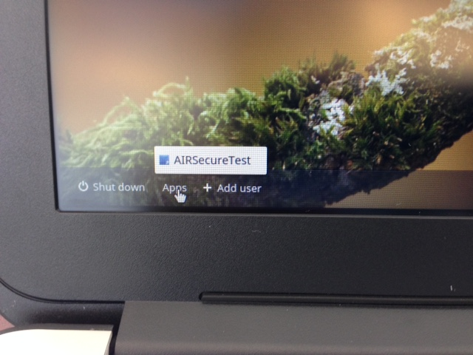

- When you first turn on the Chromebook it will show the Chrome logo. Tell the students to not log onto the Chromebook. Down on the bottom left corner they will see Apps. Click Apps and then AIRSecure Test

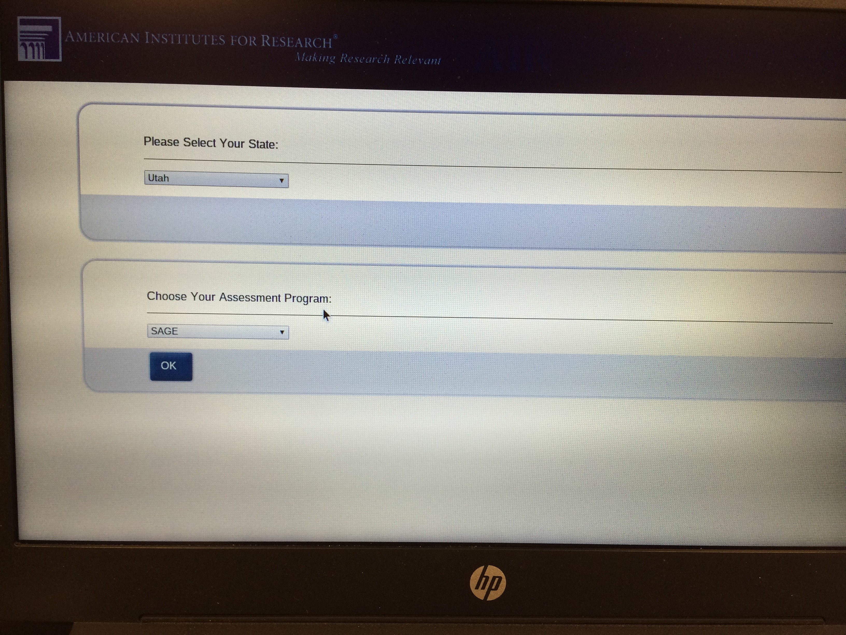

- The first time a Chromebook is booted up into the Kiosk mode it will come up to a screen where the user will need to select Utah from the first drop down menu and SAGE from the second drop down menu (which is the only available choice in the dropdown). This will only happen once on the first time the Chromebook is used for testing (once per device not per user).

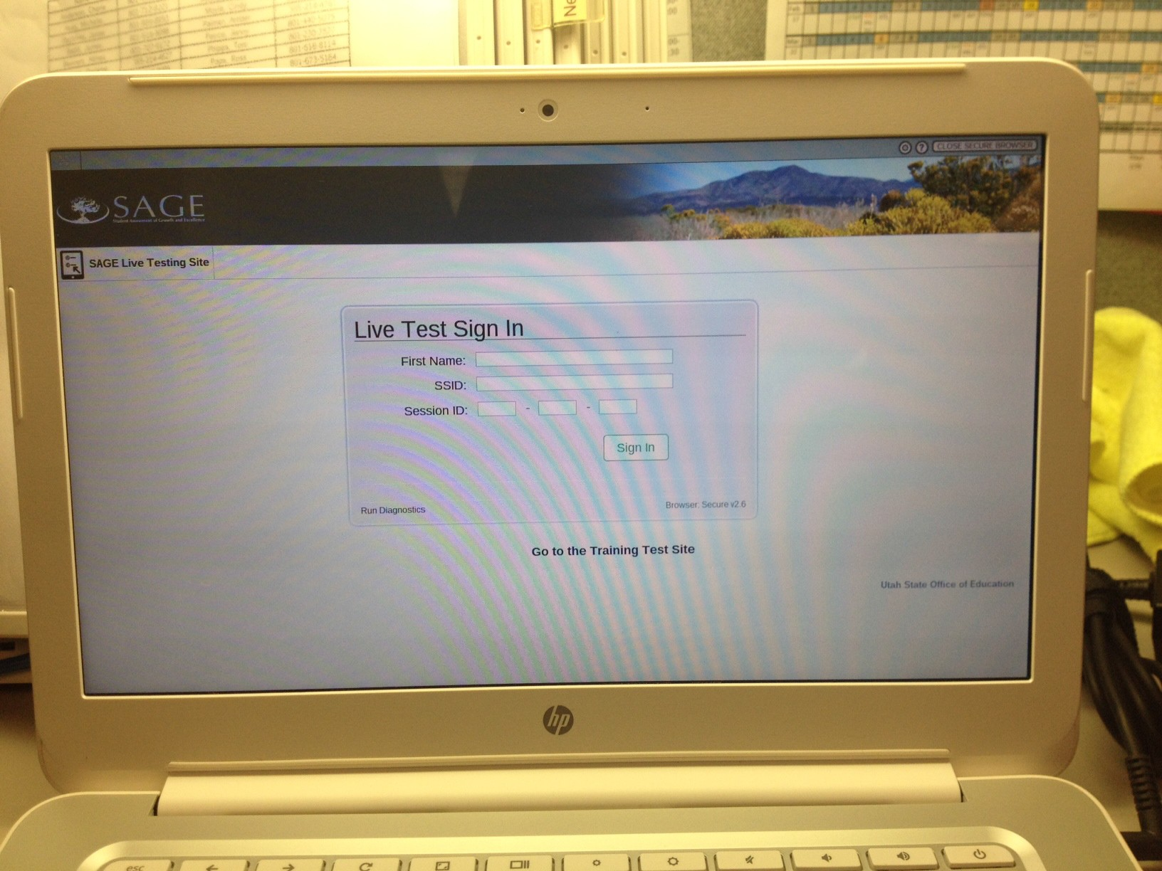

- Next, it will come up to the Live Test Sign In screen where the student will login to SAGE.

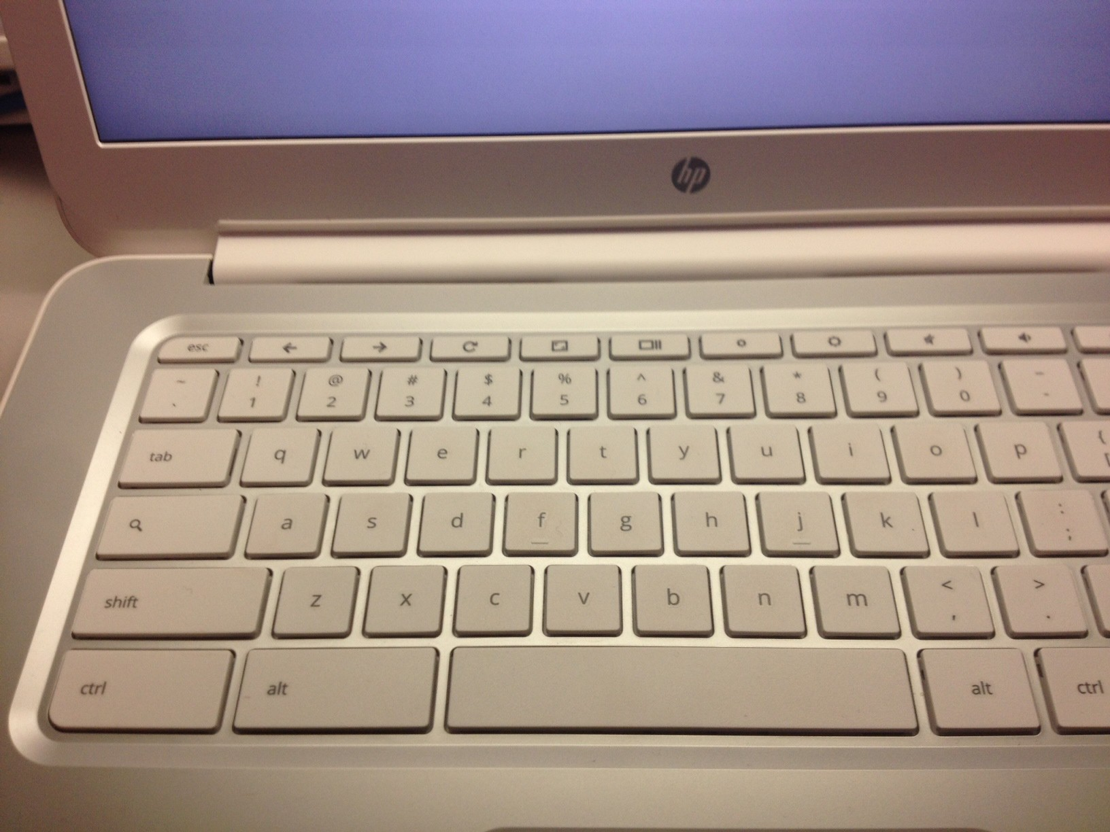
Instructions To Escape Out of the SAGE AirSecureTest Kiosk Mode at Startup

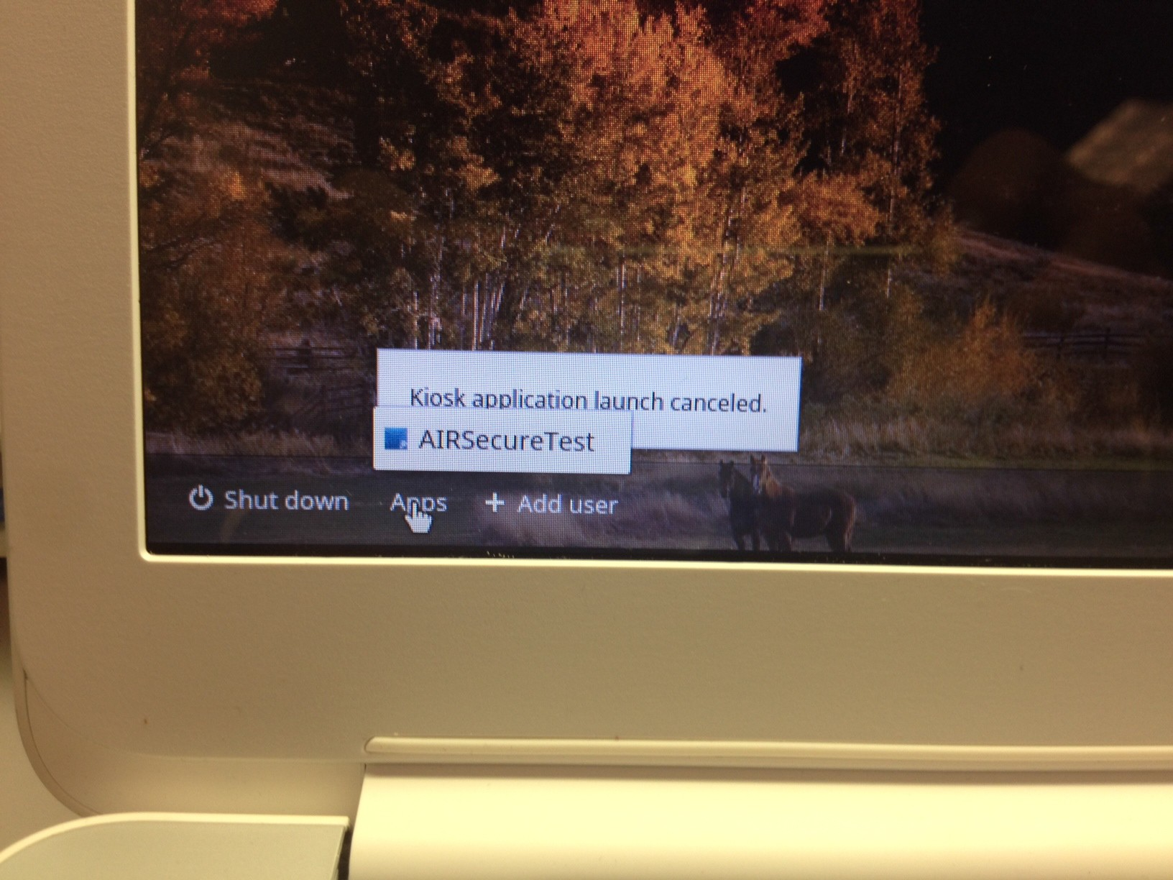
When the Chromebook is powered on, you will see the Chrome logo screen first, and then it will begin to boot into the AirSecureTest kiosk mode. When that screen first appears, you have about 3 seconds or less to press the Ctl key, the Alt key and the S key all together at the same time. It will then exit the kiosk mode and take you to the regular login screen for the Chromebook.

After escaping the kiosk mode, you will see a link called Apps in the bottom left of the screen. If at any time you want to boot back into the SAGE kiosk mode, you can click where it says Apps and then choose the AirSecureTest link. It will then begin to boot back into the SAGE kiosk mode.

