Setup Teacher Lanschool to use Dynamic class Lists
The Class lists are stored in the \\gsdshared\shared\(school_name)\Staff\Lanschool _Classlists folder and get auto-generated from Discovery that gets updated nightly.
- Verify They are connected to the correct Lanschool Connection server by opening Lanschool Teacher and go to Administer>Preferences.
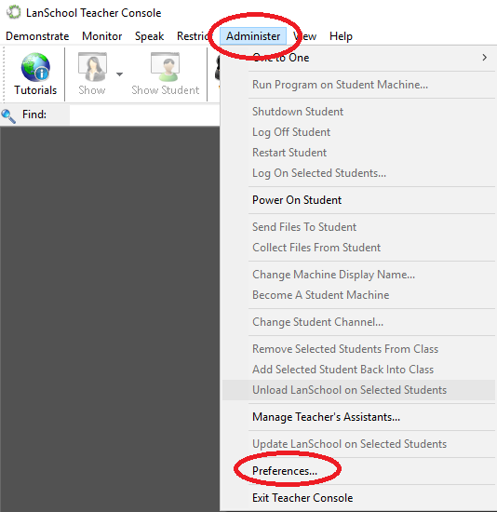
Then go to Network.
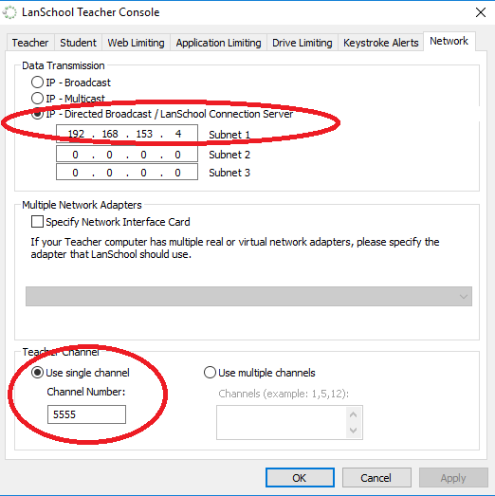
Input the Address the corresponds to the Core your school is in:
NW – 192.168.153.3
Make sure they have a channel to 7XX The X is your cart number. Apply the settings and close.
- To load the lists, click on “Class List” in the toolbar ribbon. If you do not see “Class List” as an option, you will need to click on the >> at the end of the toolbar.
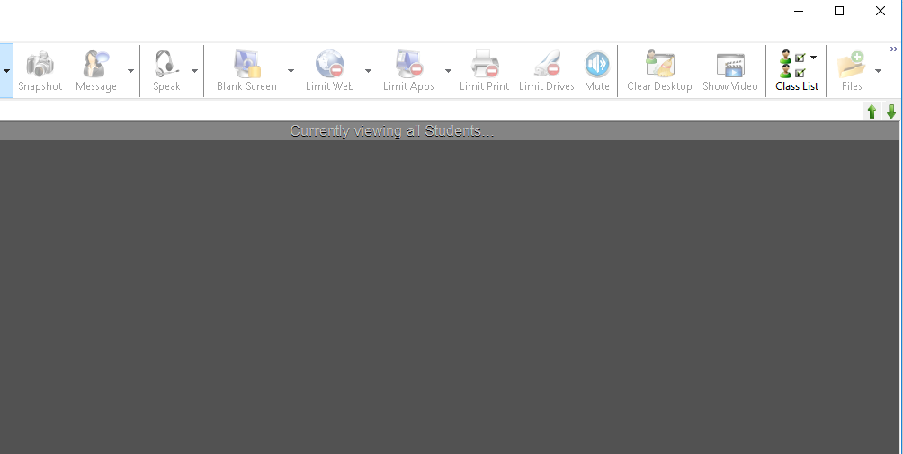

- Select “Load Dynamic Class List.”
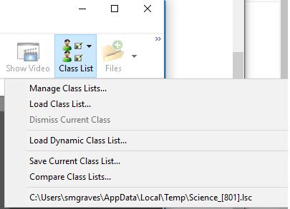

- Click on “options” and browse for the class list.
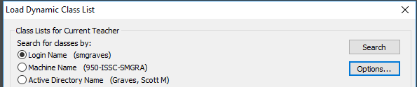
- Click “Browse” and go to \\gsdshared\shared\(school_name)\Staff\Lanschool _Classlists)

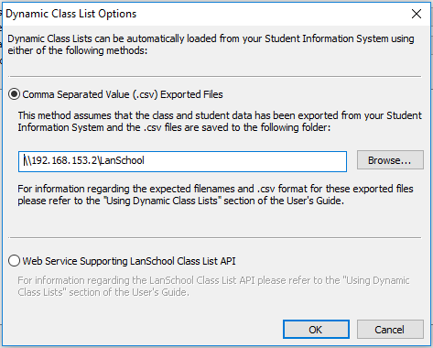
Click OK.

- Select the class you want, then click “load.”
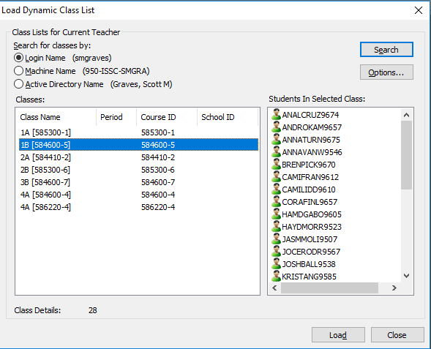
If you have already connected to a class list, you can select your list from the history section of the class list menu.

- You must disconnect or dismiss your current class so that other teachers can pull student into their class next period.
- To disconnect a class, go to the class list option and uncheck the list from the resent list.
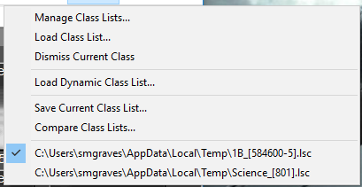

Troubleshooting
If you load your Class list and the computer tile shows as a “Missing Student” verify the username matches their Google ID. If it does not, submit a work order to have the username fixed in the exports.
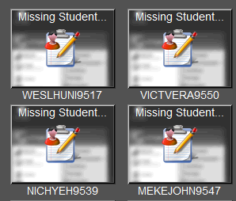
v
v
v
v

