TEST DAY INSTRUCTIONS
- PROCTOR/TEACHER COMPUTER must be logged on using your Active Directory (computer) log-in information.
- Once the computer boots open browser and go to www.sageportal.org.
- Click on the Teacher button.
- Students should log in to the computer at the same time using:
  - sage (username), Sage! (password)
  - This will directly log them into the secure testing browser.
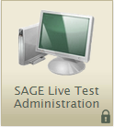
- You will need to pass out student log-in cards.
- You will then click on the SAGE Live Test Administration link/button.
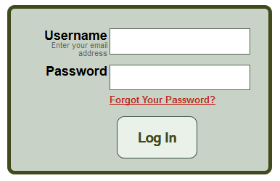
- Log-in using your email address and the password that you set (and have been using for GQB’s).
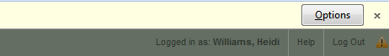
- You may get a warning that pop-ups are blocked and you have to allow them before you will be allowed to continue. At the top of the window you will see a yellow bar. Click on options and allow the pop-ups, then refresh the window.
- Starting a test session:
  - Go to the Test Selection box under the {Start Live Session} button at the top.
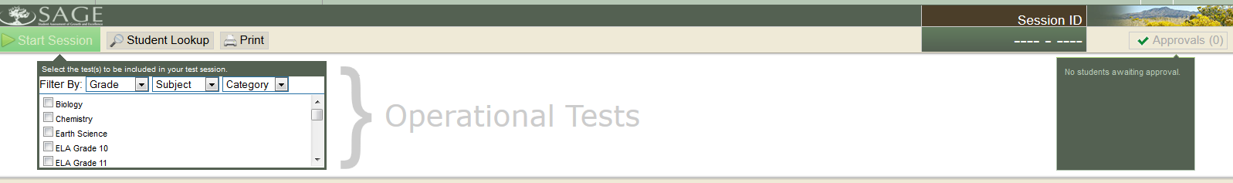
  - Click on the drop down arrow next to “Filter By: Category”; choose Summative.
  - Make sure you select the correct test. “Writing Grade (9,10.11) Summative”
  - You will want to make sure that it says “SAGE Live Tests” (which indicates that you are in the live site).
  - After selecting the test, click the {Start Session} button.
  - Session ID will be generated. You will need to provide this for students. (It will say LIVE-****-*.) If it doesn’t say LIVE you are in the wrong testing window.
  - READ THROUGH THE TAMS

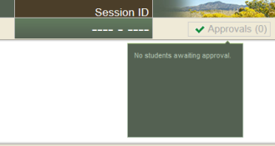
- As students log in you will begin to see numbers show up under “Approvals”.
  - Click on the “Approvals” button, and you will see a table with a list of your students who are logged in.
  - You will have to “Approve” your students before their tests will be active. You do this by approving them one at a time, or by using the Approve All button.
    - If you have students who log-in after you have already approved, you will have to go back in and approve them individually.
- You will need to monitor student progress using the “Students in Your Session table, under “Student Status”.
- At the end of your testing period you will need to stop the session (pause tests for all students in the session). (Tests that are paused for 20 minutes or more will no longer allow the student to access questions that they have already seen.)
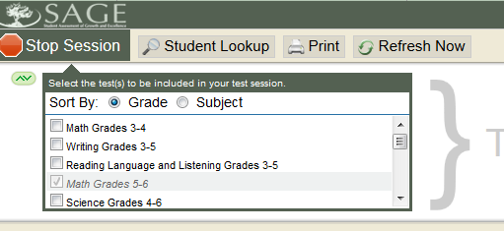
  - Click the {Stop Session} button in the upper left corner of the screen. An “Important!” box will appear, requesting verification to end the session and log students out.
  - Click {OK} to continue or {Cancel} to keep the test session open.
- Have students log off of their computers, but do not shut down. (Shut down if you are the last class of the day)
- Log off the proctor machine, but leave it powered on. (Shut down if you are the last class of the day)
- Collect any scratch paper and mark your logs. (all scratch paper must be put in the Secure Documents Bin in the front office copy room at the end of the day).
  - For session 1, place a check mark by each student who has started the test.
  - For session 2, place a check mark for every student who has completed the test.

