Setting up Newsela for the New School Year

- Log into Newsela through one of your courses in Canvas.
- Hover over Your Name in Newsela
- Click Classes
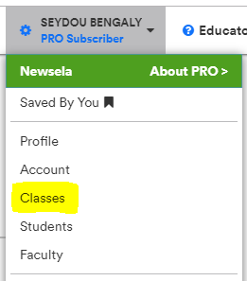

- Archive all your old classes
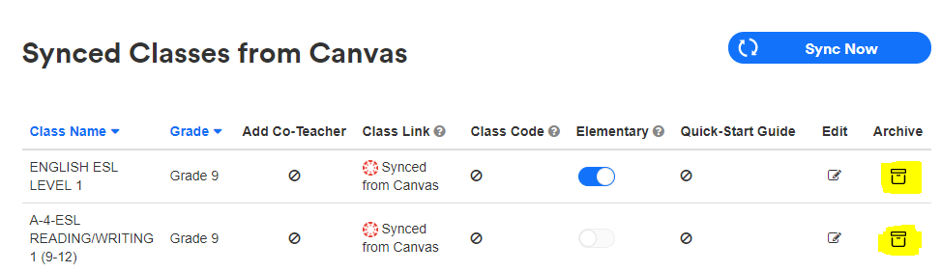

- Sync your new classes. If you sync first you may end up with multiple classes with the same name and they you have to figure out which class to archive.
- After you Sync your current classes will show up.

